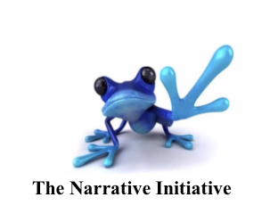
The Narrative Initiative, LLC

Presents

The 2nd Annual
Gathering of Kindness
USA
WHEN: FRIDAY May 31st, 2019 from 9:00 am – 4:00pm
Registration opens at 8:00 am
WHERE: Muhlenberg College, Seeger Union, Allentown, PA
COST: $150 per person
Attendance Limited to 100… Scholarships for students available!!
Featuring:
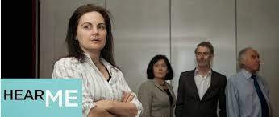

Kali Quinn
www.kaliquinn.com Solo performance
Facilitator of compassionate creativity, intergenerational dialogue & ensemble physical-based theater

Dr. Lorraine Dickey from The Narrative Initiative leading the
Narrative Kindness Workshop:
Small group
&
Large group
Narrative experience

The HUSH Foundation’s
healthcare play:
“Hear Me”
Written by: Alan Hopgood
Performed by: Bloomsburg Theater Ensemble

www.hush.org.au

**www.hushfoundation.org

WHO SHOULD ATTEND:
IF YOU WOULD LIKE TO IMPROVE YOUR HEALTHCARE EXPERIENCE
AS A PATIENT, HEALTHCARE PROVIDER, OR FAMILY MEMBER ---THEN THIS IS FOR YOU!
TNI professional narrative facilitators brings all stakeholders in the critical patient-healthcare provider relationship together through reflection on personal stories in order to:
1) examine why it is difficult to consistently find kindness in our current culture of healthcare and 2) brainstorm methods to enhance kindness in the critical patient-healthcare provider relationship.

Register for tickets at www.TheNarrativeInitiative.com
- TICKETS AVAILABLE ON-LINE AND AT REGISTRATION

FOR MORE INFORMATION CONTACT: INFO@TheNarrativeInitiative.com

The 2nd Annual
GATHERING OF KINDNESS USA
FRIDAY, MAY 31st, 2019
9:00 am – 3:00 pm
Registration 8:00 – 8:45 am
MUHLENBERG COLLEGE
Seeger Union, Room 113
Allentown, PA

8:00–8:45 REGISTRATION and Continental Breakfast
9:00-9:15 Welcome by Dr. Lorraine Dickey, CEO & Founder, TNI
9:15-10:00: Keynote Speakers: “Perspectives in Kindness”
- Healthcare: Terry Burger, BSN, MBA, Lehigh Valley Health Network
- Community: Ann Flood, CEO & Founder of Lauren’s Hope Foundation
- Schools: Curtis Dimmick, Principal of Moore Elementary School
10:00-11:00 USA Debut of The HUSH Foundation’s healthcare play: “Hear Me”
Special introduction by Dr. Catherine Crock, Founder of The HUSH Foundation
Written by Alan Hopgood
Performed by The Bloomsburg Theater Ensemble
Directed by Nicole Defenbaugh, PhD/ Co-Directed by Cassandra Pisieczko

11:00-12:00 Small group Narrative Kindness session
12:00-12:45 Break/Lunch
Lunch available for purchase in Seeger Union Cafeteria
1:00 – 2:00: Large group Narrative Kindness session & Surveys
2:00-3:00 Special performance by Kali Quinn with facilitation
3:00-3:45 Panel discussion: Dr. Crock, Dr. Dickey & Keynote Speakers
3:45-4:00 Recognitions and Final Comments
-----------------------------------------------------------------------------------------------------------------------
The Narrative Initiative, LLC
www.TheNarrativeInitiative.com
Write. Read. Renew.

